Page 1
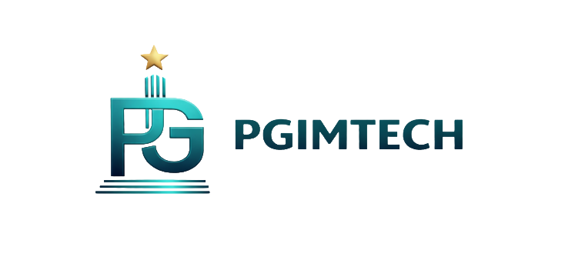 |  | 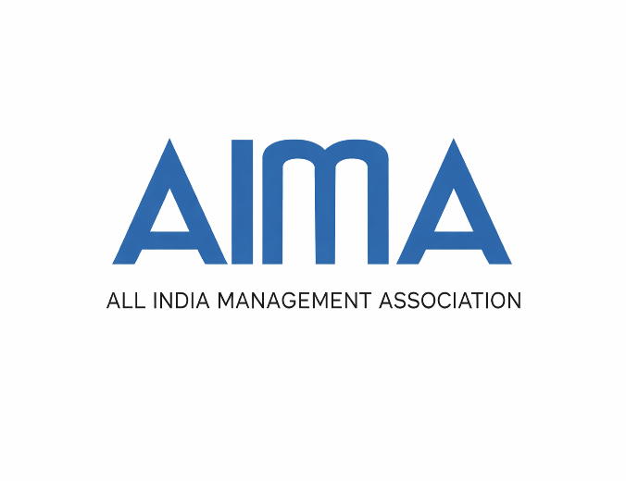
INFORMATION BROCHURE (2026-27)
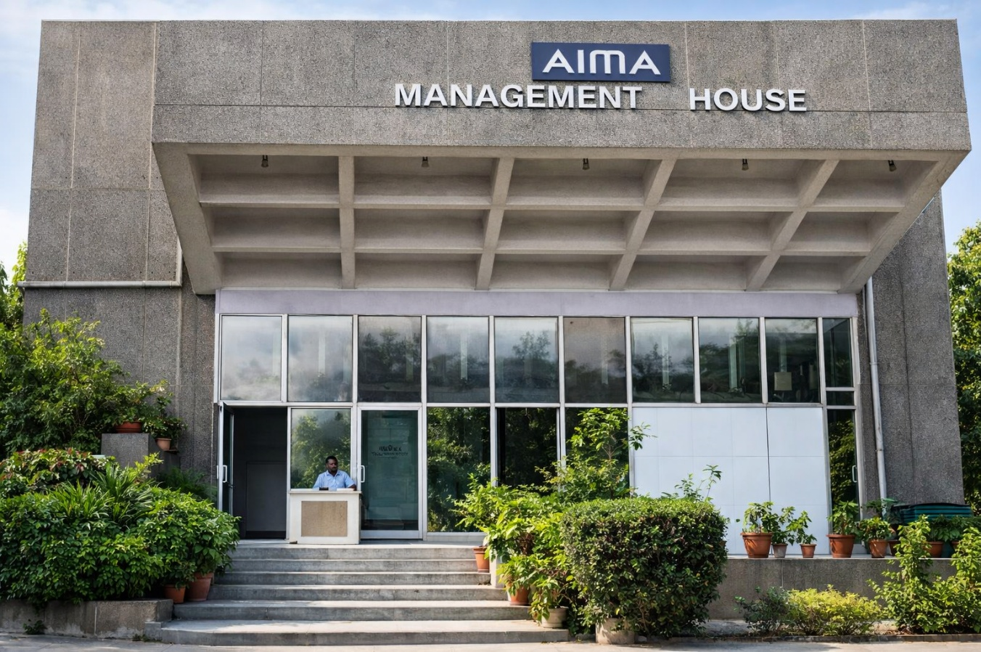
D3st Pinnacle Global Groups of Institutions’
Pinnacle Global Institute of Management and Technology – Excellence. Integrity. Innovation
Contact us: full address |  |  | QR Code leading to website
Phone nos. | Instagram |  | Facebook

Page-2(watermark images of pgimtech building and management house (aima building)
About d3st Pinnacle Global Group of Institutions, Karur
D3st Pinnacle Global Group of Institutions (PGGI), Karur, established by the d3st Pinnacle Global Educares Foundation, is a not-for-profit initiative dedicated to advancing quality education, skill development and entrepreneurship. With a vision to create an integrated learning ecosystem from pre-school to post-graduate levels, PGGI aligns with national priorities such as NEP 2020, Skill India and Make in India. Future-ready and community-driven, PGGI blends academic excellence with vocational training and entrepreneurial focus, positioning Karur as a hub for innovation and youth employability. Guided by its social mandate—Education for Empowerment and Employment—the Group fosters intellectual curiosity, ethical values and lifelong learning.
About Pinnacle Global Institute of Management and Technology (PGIMTECH)
PGIMTECH is a next-generation management institution founded to nurture bold, ethical and sustainable leaders for the 21st century. Rooted in Indian values and enriched with global perspectives, it blends academic excellence, industry relevance and a deep commitment to innovation, inclusion and impact. Our distinctive approach integrates a future-ready curriculum aligned with NEP 2020, experiential learning through internships and live projects, strong industry partnerships, and global immersion opportunities. Beyond competence, PGIMTECH emphasizes ethics, empathy and excellence—developing leaders who are tech-savvy, innovation-driven and socially responsible. With programs that transcend traditional boundaries, PGIMTECH prepares graduates to lead with clarity, compassion and creativity, building a better future for business and society.
About All India Management Association (AIMA)
Established in 1957, AIMA is the apex body of the management profession in India and the collective voice of leaders and managers nationwide. A not-for-profit, non-lobbying organization, AIMA works closely with industry, government, academia and students to advance management education and professional excellence. With over 38,000 individual members, 6,000 corporate and institutional members and 68 Local Management Associations, AIMA has a strong national presence and representation on key policy-making bodies. Over the decades, it has enhanced managerial capability through testing and assessment, distance education, skill development, executive education, research and specialized forums for young leaders, women leaders, vice-chancellors, and senior executives. Beyond its flagship PGDM programme, AIMA offers industry-oriented initiatives and global exposure through collaborations with institutions like UC Berkeley, St. Gallen Symposium, Horasis, and The World Bank, while being a long-standing member of AAMO.

Page-3
Post Graduate Diploma in Management (PGDM)
(In association with All India Management Association – AIMA | Approved by AICTE)
Two-Years Program | Blended Learning Format
Begin a transformative academic and professional journey with the Post Graduate Diploma in Management (PGDM) at Pinnacle Global Institute of Management Technology. This two-year program, in association with the All India Management Association (AIMA) and approved by AICTE, is designed to equip learners with both foundational and advanced knowledge in business management.
Specializations Offered
PGIMTECH is offering the following specialization under PGDM Program for the session (2026-28):
- Banking and Financial Management
- Marketing Management
- Technology and Operations Management
Program Duration and Learning Pedagogy
The Post Graduate Diploma in Management (PGDM) program has a minimum duration of two years, inclusive of internships and project work.
The program adopts a robust blended learning pedagogy, combining academic rigour with applied learning:
- Value-added offline regular classes, conducted by faculty of PGIMTECH, for conceptual clarity and practical understanding.
- Weekend live online interactive sessions conducted by AIMA faculty and seasoned industry experts, ensuring exposure to real-world global business insights.

PGDM CURRICULUM
SEMESTER - 1
BUSINESS STATISTICS
MANGERIAL ECONOMICS
MANAGEMENT FUNCTIONS AND ORGANIZATIONAL BEHAVIOUR
FINANCIAL ACCOUNTING AND ANALYSIS
COMMUNICATION FOR MANAGERS
MANAGEMENT INFORMATION SYSTEM
EXPERIENTIAL LEARNING PROJECT
Life Transformation Centre - 1
Managerial Competency Development - 1
Workshop on Excel for Managers

SEMESTER -2
MARKETING MANAGEMENT
FINANCIAL MANAGEMENT
PRODUCTION & OPERATIONS MANAGEMENT
HUMAN RESOURCE MANAGEMENT
BUSINESS ENVIRONMENT
RESEARCH METHODOLOGY
SOCIAL PROJECT
Life Transformation Centre - 2
Managerial Competency Development - 2
Workshop on AI Tools in Management

SEMESTER - 3 (SPECIALIZATIONS- Students are required to choose one specialization in Semester - 3)
BUSINESS ANALYTICS
BUSINESS SIMULATION
SPECIALIZATION – PAPER 1
SPECIALIZATION – PAPER 2
SPECIALIZATION – PAPER 3
SPECIALIZATION – PAPER 4
SPECIALIZATION – PAPER 5
SIX MONTHS’ SUMMER INTERNSHIP
Campus to Corporate – Placement Readiness Program

SEMESTER - 4
EMERGING TECHNOLOGIES AND ITS APPLICATION IN MANAGEMENT
STRATEGIC MANAGEMENT
BUSINESS ETHICS AND CORPORATE GOVERNANCE
ENTREPRENEURSHIP, INNOVATION & STARTUPS
SUSTAINABILITY MANAGEMENT & CORPORATE SOCIAL RESPONSIBILITY

CAPSTONE PROJECT

CHOOSE ANY ONE SPECIALIZATION IN SEMESTER - 3
SPECIALIZATION - MARKETING MANAGEMENT
SALES AND DISTRIBUTION MANAGEMENT
MARKETING OF SERVICES
DIGITAL MARKETING
PRODUCT & BRAND MANAGEMENT
CUSTOMER RELATIONSIHP MANAGEMENT

SPECIALIZATION - TECHNOLOGY AND OPERATIONS MANAGEMENT
PROJECT MANAGEMENT
TECHNOLOGY MANAGEMENT
LOGISTICS & SUPPLY CHAIN MANAGEMENT
QUALITY MANAGEMENT AND SIX SIGMA
SERVICE OPERATIONS MANAGEMENT

SPECIALIZATION - BANKING AND FINANCIAL MANAGEMENT
RETAIL BANKING
BANKING FINANCIAL MANAGEMENT
RISK MANAGEMENT IN BANKS
FINTECH
MANAGEMENT OF FINANCIAL SERVICES

Page 4
Post Graduate Certificate in Management (PGCM) in Entrepreneurship and Family Business
(In association with All India Management Association – AIMA | Approved by AICTE)
One- Year Work-Integrated Program | Blended Learning Format
If you carry the spark of innovation and the ambition to build, scale or transform a business, the PGCM in Entrepreneurship and Family Business is designed for you. This program is a catalyst for entrepreneurial leadership - empowering individuals to convert ideas into sustainable enterprises and legacy-driven businesses into professionally managed organizations.
The program is purpose-built to ignite and strengthen the entrepreneurial mindset, equipping learners with end-to-end business capabilities. From idea generation, opportunity identification and business model design to modern marketing strategies, digital transformation, legal frameworks, financial planning and long-term business sustainability - this program prepares you to navigate complexity, manage uncertainty and make confident strategic decisions.
By blending entrepreneurial thinking with practical execution, the PGCM develops resilient leaders who can create value, drive innovation and lead businesses through growth, transition and transformation.
Program Duration and Learning Pedagogy
The PGCM in Entrepreneurship and Family Business is a one-year, work-integrated program, enabling learners to pursue advanced management education without interrupting their professional journeys.
The program follows a robust blended learning pedagogy, combining academic depth with hands-on application:
- Value-added offline contact classes, conducted periodically by PGIMTECH, to strengthen conceptual understanding and applied business skills
- Weekend live online interactive sessions led by AIMA faculty and experienced industry practitioners, offering exposure to real-world entrepreneurial insights and best practices
- Work-based applied projects, wherein working professionals undertake an annual project aligned with their business or organizational role, supported by semester-wise reports, presentations and viva-voce evaluations
This immersive approach ensures learning is immediately applicable to real entrepreneurial and business challenges.
Curriculum
SEMESTER -1
Entrepreneurial Process and Opportunity Recognition
Entrepreneurial Marketing

Business Model Development

Design Thinking

Life Transformation Centre - 1
Experiential learning project
Managerial Competency Development - 1

SEMESTER -2
Legal Aspects of Business
Entrepreneurial Finance

Entrepreneurial Leadership
Digitization of Business
Entrepreneurship Capstone/Live Project

Life Transformation Centre - 2
Managerial Competency Development - 2

Page 5
Post Graduate Certificate in Management (PGCM) in International Business
(In association with All India Management Association – AIMA | Approved by AICTE)
One- Year Work-Integrated Program | Blended Learning Format
The Post Graduate Certificate in Management (PGCM) in International Business is a future-ready program crafted to develop globally competent managers and leaders capable of navigating the complexities of international markets. Designed for the dynamic global business environment, the program empowers learners with strategic insights, practical expertise and a strong international outlook.
The curriculum delivers an integrated and contemporary understanding of international marketing strategies, global trade policies, export–import management, trade finance instruments, cross-border documentation and International Human Resource Management. With a strong emphasis on both strategic decision-making and operational execution, the program strikes a rare and powerful balance between international business theory and real-world export–import practices.
By fostering global business acumen and cross-cultural understanding, the PGCM in International Business enables learners to think beyond borders, adapt to diverse markets and confidently contribute to organizations operating in the global arena.
Program Duration and Learning Pedagogy
The PGCM in International Business is a one-year, work-integrated program, thoughtfully designed to allow learners to pursue advanced management education alongside their professional commitments.
The program adopts a robust blended learning pedagogy, combining academic rigour with applied learning:
- Value-added offline contact classes, periodically conducted by PGIMTECH, to reinforce conceptual clarity and practical understanding.
- Weekend live online interactive sessions conducted by AIMA faculty and seasoned industry experts, ensuring exposure to real-world global business insights.
- Work-based learning projects, where working professionals undertake an annual project aligned with their professional roles, supported by semester-wise reports, presentations and viva-voce evaluations.

Curriculum

SEMESTER -1
International Economics, Geopolitics & Trade Policy
International Marketing & Cross-Cultural Negotiation
International Finance, Trade Finance & FX Risk Management
Global Supply Chain, Logistics & Trade Operations
Life Transformation Centre - 1
EXPERIENTIAL LEARNING PROJECT
Managerial Competency Development - 1

SEMESTER -2
Global business strategy & competitive advantage
International business law, contracts, compliance & ethics
Export–import management & digital documentation
Market entry, partnering & international business development
Project work: international business capstone / live project
Life Transformation Centre - 2
Managerial Competency Development - 2

Page 6
PGIMTECH - PGDM DIFFERENTIATORS (show through graphics)
- Case Study Methodology
- Classroom Simulations
- Managerial Competency Modules
- Ideation & Business Design Lab
- 6-month Summer Internships
- Industry Guest Talks
- Industrial Visits
- Annual Management Fest
- Campus to Corporate - Placement Readiness Program
- Experiential Learning Projects
- Social Projects
- Capstone Project
- Life Transformation Centre - Yoga, Meditation, Outbound Training, Mental Well-being, Happiness Quotient, Behavioral Lab, Psychometric Assessments, Communication Lab, etc.
- Value-added skills certifications
- Software & Tools – CESIM, Power BI, Tableau, Salesforce, SAP, Artificial Intelligence
- 100 percent placement assistance

Page 7
Eligibility for Admission
- Completed undergraduate degree with a minimum of 50% marks from a recognized university
- Score of a competitive entrance exam such as CAT, MAT, XAT, CMAT, ATMA or any other test score (if available)
- Professional work experience (if available)
- Proficiency in English
- Excellent communication skills
- Strong commitment to personal and professional growth

How to Apply?
Application Process
- Submission of Application Form along with the application fees and all necessary documents
- SOP (Statement of Purpose) – around 250 words describing why do you want to join the PGDM/PGCM Program (in .pdf file format to be sent to admissions@pgimtech.in ). It can cover your career history, qualifications, professional goals and your ideas about the future career opportunities for you.
- Video Introduction – one minute video byte describing about yourself (to be sent to admissions@pgimtech.in)

Availability of application Form
In person
The Application Form can be collected in person and submitted, by paying an amount of Rs.2000/- from:
Pinnacle Global Institute of Management Technology (PGIMTECH)

Ph. , Mob.:
Email:

Download Application Form
Applicants can alternatively download the Application Form from the PGIMTECH website. The downloaded form is to be duly filled in by the applicant and sent to PGIMTECH address along with a Demand Draft of Rs. 2000/- drawn in favour of “d3st Pinnacle Global Educares Foundation” payable at Karur, Tamil Nadu, towards the payment of application processing fee.

Documents Required
- 10th Marksheet and Certificate
- 12th Marksheet and Certificate
- Bachelor’s All Semester Marksheets
- Bachelor’s degree Certificate
- ⁠College Leaving Certificate
- Entrance Exam Score Card (if appeared)
- Experience Certificate (if applicable)
- ⁠3 passport size photographs
- Copy of Aadhar Card
- Address Proof self/local guardian

Selection Process

After submission of application form with all necessary documents, you will be invited to face the personal interview online for which the date and time will be intimated to you in advance.

- Personal Interview will be conducted by the institute faculty or industry expert.

- The result will be communicated to you within one week of completion of selection process.

Page 8
Corporate Relations and Placement Cell (CRPC)
The Corporate Relations and Placements Cell (CRPC) at PGIMTECH serves as a strategic interface between academia and industry, playing a pivotal role in shaping students into future-ready, employable and high-performing management professionals.
Key Activities and Initiatives (Show through graphics)
Industry Guest Lectures (‘Campus Talk’ Series): Distinguished industry leaders and domain experts are invited to campus to share insights on emerging trends, leadership challenges and practical business perspectives.
Industrial Visits: Structured industry visits provide students with firsthand exposure to organizational practices, operational environments and corporate cultures.
Career Development and Employability Training: Comprehensive career readiness support, including resume writing, interview preparation and mock interviews, group discussions and aptitude training as well as professional mentoring support
Placements and Internships: Summer internships, live projects and final campus placements aligned with corporate hiring standards

Career Planning and Counselling Services (CPCS)
At PGIMTECH, career development is not an afterthought - it is a strategic, structured and continuous process that runs parallel to academic and leadership development. Our Career Planning and Counselling Services are designed to empower students with clarity, confidence and direction, enabling them to make informed career choices and build sustainable professional futures.
A Structured Pathway from Classroom to Career
PGIMTECH offers personalized career planning and counselling sessions that help students identify their strengths, interests and long-term aspirations. These sessions guide students in:
- Selecting the most relevant electives and specialization pathways
- Exploring diverse career opportunities across industries and functional domains
- Understanding corporate expectations, industry trends and emerging career roles
This comprehensive approach ensures that students are not only academically prepared but are also, strategically aligned with the evolving demands of the business world.

LOCATION MAP
ADDRESS DETAILS
PHONENO; EMAIL (ADMISSION); WEBSITE:

